Student Sheets: Producing electricity using hydropower

In this activity we will build a model turbine connected to a generator to produce electricity. We will demonstrate the relationship between the amount of kinetic energy in falling water and the amount of electrical energy produced by having the water fall from various heights. The amount of electrical energy will be determined by using a multimeter to measure the voltage produced by the model turbine in units of volts.

Kinetic energy is the energy of motion. A hydro-electric power dam uses the concept of kinetic energy in fast flowing water to produce electricity.
Take a look at how a basic hydro-electric power dam is set up in the diagram below.
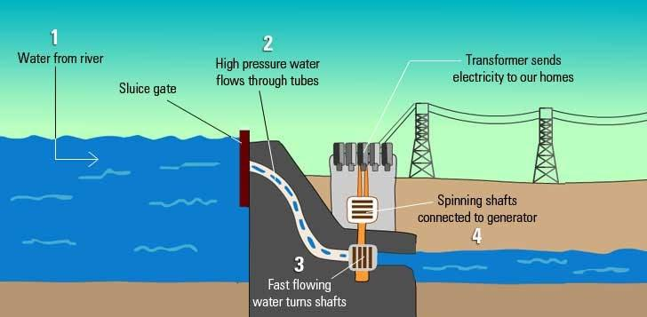
1. Water from a stream or river is held up (blocked) by the sluice gate. Holding up more water increases potential energy and gravitational energy.
2. The gates are then opened. Water rushes down through the gate and into the tubes. There is immense kinetic energy in the very fast flowing water because of the high pressure it has.
3. Kinetic energy in the fast-flowing water turns shafts (blades) connected to the end of the tubes. More fast flowing water means more blades can be turned even faster.
4. The spinning blades or shafts are connected to a generator which generates electricity. The generator is connected to a transformer which changes the electricity to the proper voltage so that it can be sent to our homes, businesses and other electricity customers.
Materials:
Black Hub from the Kid Wind wind kit
Motor from the Kid Wind solar Kit
6 Mini wooden spoons for paddles
2 alligator clips
Multimeter from the Kid Wind wind kit
Tape Measure
Water source - 2L pop bottle with water inside.
Tub to catch water

Procedure:
- Connect the wooden spoons to the hub making sure all the paddles are facing the same direction.
- Connect the hub to the motor.
- Connect the alligator clips to the pins on the back of the motor.
- Connect the other end of the alligator clips to the multimeter, and turn the multimeter to 20 DVC.
- Working as a team, have one person hold the tape measure, one to read the multimeter, one to pour the water, and one to make sure the water is going in the tub. Someone also needs to be responsible for recording the results. Pour the water over the paddles from a height of 1 meter, with the water falling in the tub. Record the voltage from the multimeter in the data table.
- Repeat except pour the water over the paddles from a height of 50 cm. Record your results in the data table.
- Repeat except pour the water over the paddles from a height of 25cm. Record your results in the data table.

Look at the picture below to make sure you have connected everything correctly.
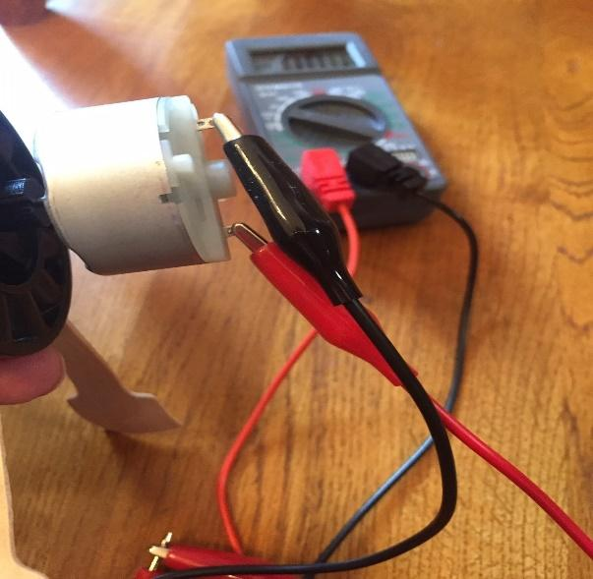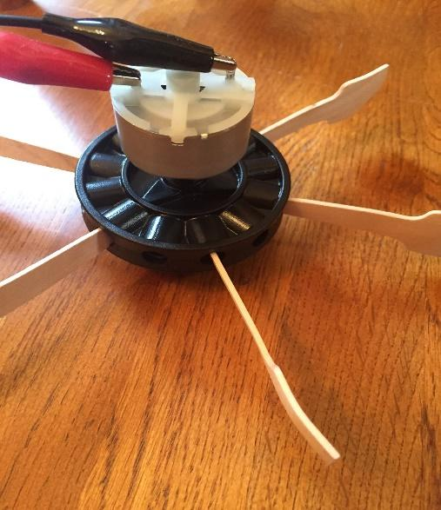

DATA TABLE

Height of water | Volts 1st trial | Volts 2nd trial | Volts 3rd trial
1 meter
50 cm
25 cm

EXPLANATION:
1.Did changing the height of where the water was poured from make a difference in the voltage? Why or why not?

2. Looking at the data table, at what height was the largest voltage produced?

3. Which height had the greatest potential energy?

4. Where is the kinetic energy?

5. Where in a dam would you find the turbine that the water goes through?

6. Does the height of a dam make a difference in the amount of electricity that is produced?

7. Where in the dam would the kinetic energy be the greatest?

8. What was your independent variable in this experiment?

9. What was the dependent variable in this experiment?

10. What were the constant variables?

EVALUATION:

- How is electricity produced in a hydropower plant?

- What are the factors that affect the amount of electricity that can be produced in a hydropower plant?

- Before the water flows through the dam, does it have potential or kinetic energy? Explain.

